**PROGRAM 2**

**BANKING ENTERPRISE DATABASE**

**Consider the following database for a banking enterprise.**

**BRANCH (branch-name: String, branch-city: String, assets: real)**

**ACCOUNTS (accno: int, branch-name: String, balance: real)**

**DEPOSITOR (customer-name: String, customer-street: String, customer-city: String)**

**LOAN (loan-number: int, branch-name: String, amount: real)**

**BORROWER (customer-name: String, loan-number: int)**

**i. Create the above tables by properly specifying the primary keys and the foreign keys**

use Supriya;

create table branch

(

branch_name varchar(20),

branch_city varchar(20),

assets real,

primary key(branch_name));

desc branch;

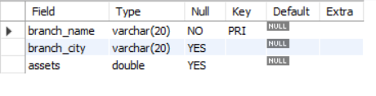

use Supriya;

create table accounts

(

branch_name varchar(20),

acc_no integer,

balance real,

primary key(acc_no),

foreign key(branch_name)references branch(branch_name));

desc accounts;

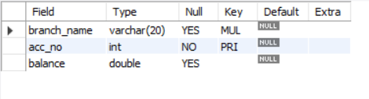

create table depositor

(

customer_name varchar(20),

customer_street varchar(20),

customer_city varchar(20),

primary key(customer_name));

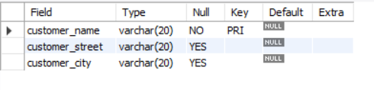

create table loan

(

loan_number int,

branch_name varchar(20),

amount real,

primary key(loan_number),

foreign key(branch_name)references branch(branch_name)

);

desc loan;

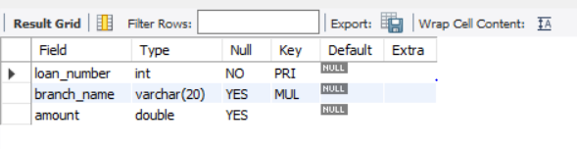

create table borrower

(

customer_name varchar(20),

loan_number int,

primary key(loan_number),

foreign key(customer_name)references depositor(customer_name),

foreign key(loan_number)references loan(loan_number));

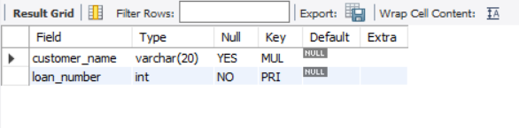

**ii. Enter at least five tuples for each relation.**

use Supriya;

insert into branch values('SBI','Bangalore','25.6');

insert into branch values('Vijaya','Hubli','30.6');

insert into branch values('Syndicate','Dharwad','50.6');

insert into branch values('canara','Davangere','60.6');

insert into branch values('karnataka_bank','udupi','70.6');

select * from branch;

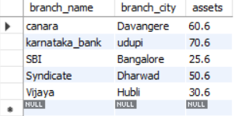

insert into accounts values('SBI','12345','25000.6');

insert into accounts values('Vijaya','23456','30000.6');

insert into accounts values('Syndicate','345678','50000.6');

insert into accounts values('canara','456789','60000.6');

insert into accounts values('karnataka_bank','876543','70000.6');

insert into accounts values('SBI','54321','75000.6');

select * from accounts;

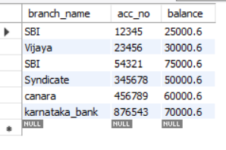

insert into depositor values('Ravi','vidyagiri','Dharwad');

insert into depositor values('Vidya','chamrajpet','Bangalore');

insert into depositor values('Ram','Vidyanagar','Hubli');

insert into depositor values('Raj','basavangudi','Bangalore');

insert into depositor values('kiran','keshwanpur','Davangere');

select * from depositor;

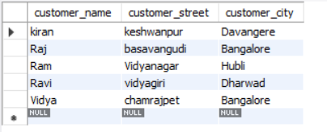

insert into loan values('1','SBI','25000.6');

insert into loan values('2','Vijaya','30000.6');

insert into loan values('3','Syndicate','50000.6');

insert into loan values('4','canara','60000.6');

insert into loan values('5','karnataka_bank','70000.6');

select * from loan;

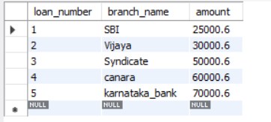

insert into borrower values('kiran',1);

insert into borrower values('Raj',2);

insert into borrower values('Ram',3);

insert into borrower values('Ravi',4);

insert into borrower values('Vidya',5);

select * from borrower;

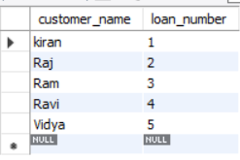

**iii. Find all the customers who have at least two accounts at the Main branch.**

select c.customer_name

from bank_customer c

where exists(

select d.cust_name

from depositer d, bank_account ba

where

d.accno=ba.accno and

c.customer_name=d.cust_name and

ba.branch_name='SBI_chandralayout'

group by d.cust_name

having count(d.cust_name)>=2

);

**iv. Find all the customers who have an account at all the branches located in a specific city.**

select d.cust_name from depositer d,branch b,bank_account ba

where b.branch_name=ba.branch_name

AND ba.accno=d.accno

and branch_city='Delhi'

group by d.cust_name

having COUNT(distinct b.branch_name)=(select COUNT(branch_name) from branch where branch_city='Delhi');

**v. Demonstrate how you delete all account tuples at every branch located in a specific city.**

use Supriya;

delete from accounts where branch_name IN(select branch_name from branch where branch_city='Hubli');

select * from accounts;

